
The Baptism of Our Lord

CHRIST LUTHERAN CHURCH | Lodi, California
January 11, 2026

WELCOME TO WORSHIP
Welcome to Christ Lutheran Church. We pray that your soul will be strengthened by the good news about God’s grace, love, and forgiveness given to us. If you would like to learn more about our church, please speak with our pastor or one of our members after the service.
- Bathrooms are located in the fellowship hall. A changing table is located in the women’s bathroom.
WORSHIP THEME
Jesus was baptized at the Jordan to reveal himself as the Son of God. This identity is a great comfort for us: we know that he is able to do what we cannot. In him, through baptism, we become children of God, holy and pleasing in our Father’s sight.
Epiphany means “to reveal.” During this season of the church year, we see how Jesus reveals himself as the Son of God and the Savior of the world. We especially learn from his teaching that he is the Wisdom from on High and the Word of God made flesh. From his teaching, we learn what our own identities are in him.

The Service of the Word
We gather as a congregation to hear God’s Word proclaimed and respond with prayer, praise, and thanksgiving.
HYMN Hail to the Lord’s Anointed| CW 384
M: In the name of the Father, and of the Son, and of the Holy Spirit.
C: Amen.

CONFESSION
M: We have come into the presence of God, who created us to love and serve him as his dear children. But we have disobeyed him and deserve only his wrath and punishment. Therefore, let us confess our sins to him and plead for his mercy.
C: Merciful Father in heaven, I am altogether sinful from birth. In countless ways I have sinned against you and do not deserve to be called your child. But trusting in Jesus my Savior I pray: Have mercy on me according to your unfailing love. Cleanse me from my sin and take away my guilt.

absolution
M: God, our heavenly Father, has forgiven all your sins. By the perfect life and innocent death of our Lord Jesus Christ, he has removed your guilt forever. You are his own dear child. May God give you strength to live according to his will.
C: Amen
M: In the peace of forgiveness, let us praise the Lord.

O Taste and See
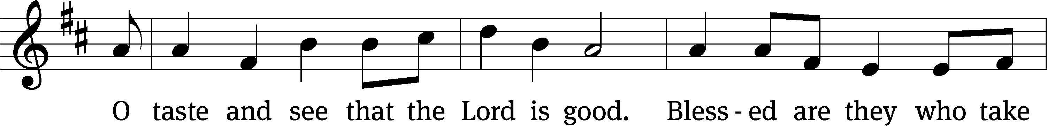
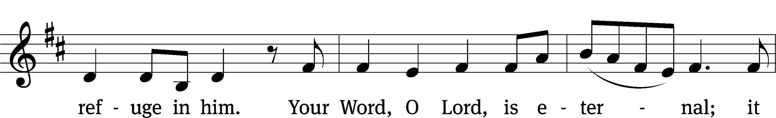


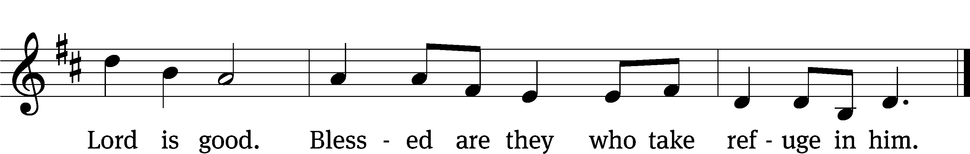
PRAYER OF THE DAY
M: Let us pray.
Father in heaven, at the baptism of Jesus in the River Jordan, you proclaimed him your beloved Son and anointed him with the Holy Spirit. Keep us who are baptized into Christ faithful in our calling as your children, and make us heirs with him of everlasting life; through your Son, Jesus Christ our Lord, who lives and reigns with you and the Holy Spirit, one God, now and forever.
C: Amen
FIRST LESSON Isaiah 42:1–7
The Servant of the Lord comes to set his people free.
“Here is my servant, whom I uphold,
my chosen one in whom I delight;
I will put my Spirit on him,
and he will bring justice to the nations.
He will not shout or cry out,
or raise his voice in the streets.
A bruised reed he will not break,
and a smoldering wick he will not snuff out.
In faithfulness he will bring forth justice;
he will not falter or be discouraged
till he establishes justice on earth.
In his teaching the islands will put their hope.”
This is what God the Lord says—
the Creator of the heavens, who stretches them out,
who spreads out the earth with all that springs from it,
who gives breath to its people,
and life to those who walk on it:
“I, the Lord, have called you in righteousness;
I will take hold of your hand.
I will keep you and will make you
to be a covenant for the people
and a light for the Gentiles,
to open eyes that are blind,
to free captives from prison
and to release from the dungeon those who sit in darkness.
PSALM Psalm 45
SECOND LESSON Acts 10:34–38
Jesus’ identity is good news for people of all nations.
Then Peter began to speak: “I now realize how true it is that God does not show favoritism but accepts from every nation the one who fears him and does what is right. You know the message God sent to the people of Israel, announcing the good news of peace through Jesus Christ, who is Lord of all. You know what has happened throughout the province of Judea, beginning in Galilee after the baptism that John preached— how God anointed Jesus of Nazareth with the Holy Spirit and power, and how he went around doing good and healing all who were under the power of the devil, because God was with him.
VERSE OF THE DAY Mark 1:11
Alleluia. You are my Son, whom I love; with you I am well pleased. Alleluia.
THE GOSPEL Matthew 3:13–17
Jesus is baptized by John in the Jordan.
Then Jesus came from Galilee to the Jordan to be baptized by John. But John tried to deter him, saying, “I need to be baptized by you, and do you come to me?”
Jesus replied, “Let it be so now; it is proper for us to do this to fulfill all righteousness.” Then John consented.
As soon as Jesus was baptized, he went up out of the water. At that moment heaven was opened, and he saw the Spirit of God descending like a dove and alighting on him. And a voice from heaven said, “This is my Son, whom I love; with him I am well pleased.”
M This is the Gospel of the Lord.
C: Praise be to you, O Christ!
HYMN OF THE DAY To Jordan’s River Came our Lord| CW 377
SERMON Matthew 3

APOSTLES’ CREED
I believe in God, the Father Almighty,
maker of heaven and earth.
I believe in Jesus Christ, his only Son, our Lord,
who was conceived by the Holy Spirit,
born of the Virgin Mary,
suffered under Pontius Pilate,
was crucified, died, and was buried.
He descended into hell.
The third day he rose again from the dead.
He ascended into heaven
and is seated at the right hand of God the Father Almighty.
From there he will come to judge the living and the dead.
I believe in the Holy Spirit,
the holy Christian Church,
the communion of saints,
the forgiveness of sins,
the resurrection of the body,
and the life everlasting. Amen.
OFFERING
In response to God’s love and forgiveness, we give back a portion of what he has given us. The members of Christ Lutheran Church have joined to proclaim the gospel to this community. These offerings support that work. While our guests are welcome to participate, they should not feel obligated to do so.
PRAYER OF THE CHURCH
M: Heavenly Father, You have revealed Your Son to us in the wondrous Epiphany in the Jordan. So also You have revealed Your name and blessing to us in Holy Baptism, declaring us Your beloved heirs. Grant that we may daily die to sin and rise to newness of life, living with joy as Your baptized children. Lord, in Your mercy,
C: Hear our prayer.

M: Lord God, as You have opened heaven to Your Church through Holy Baptism, give her faithful teachers to proclaim Your Son, Jesus Christ, and all that accords with godliness, that many would repent of their sins and join Him in His kingdom. Lord, in Your mercy,
C: Hear our prayer.
M: O Lord, preserve the family, especially all Christian homes. Turn husband and wife toward one another in love, equip fathers and mothers for their holy duty as teachers of the faith, and preserve all children in the saving faith and certain promises of their Baptism unto life everlasting. Lord, in Your mercy,
C: Hear our prayer.
M: O God, Your Son, Jesus, is the Christ and the true King of this world. Grant great humility to the rulers of the nations, that they would submit to the preaching of His Holy Word for the sake of their own souls and for the good of all people. Lord, in Your mercy,
C: Hear our prayer.
M: Almighty Lord, You sent Your Son to serve Your people and deliver them from sin and death. Because we long for Your salvation, bring us out of our afflictions and uphold all those bruised in spirit [especially _____________]. Lord, in Your mercy,
C: Hear our prayer.
M: O Lord, our God, You have brought eternal life to us through the death of Your Son. Grant that we who have come through Baptism and have died to this world would ever more and more live in the resurrected life of Christ. Lord, in Your mercy,
C: Hear our prayer.
M: Lord God, heavenly Father, You and the Holy Spirit showed the fullness of your grace at the Baptism of Your dear Son. With Your voice, You directed us to the One who has borne our sins, that we may receive grace and forgiveness. Keep us in the true faith. Since we have been baptized in accordance with Your command and the example of Your Son, strengthen our faith by Your Holy Spirit and lead us to everlasting life and salvation; through the same Jesus Christ, Your Son, our Lord, who lives and reigns with You and the Holy Spirit, one God, now and forever.
C: Amen.

LORD’S PRAYER
C: Our Father, who art in heaven, hallowed be thy name,
thy kingdom come, thy will be done on earth as it is in heaven.
Give us this day our daily bread; and forgive us our trespasses,
as we forgive those who trespass against us;
and lead us not into temptation, but deliver us from evil.
For thine is the kingdom and the power and the glory
forever and ever. Amen.
M: O Lord God, our heavenly Father, pour out the Holy Spirit on your faithful people. Keep us strong in your grace and truth, protect and comfort us in all temptation, and bestow on us your saving peace, through Jesus Christ, our Lord.
C: Amen.
THE BLESSING
M: The Lord bless you and keep you.
The Lord make his face shine on you and be gracious to you.
The Lord look on you with favor and ✙ give you peace.
C: Amen.
CLOSING HYMN God’s Own Child I Gladly Say It| CW 679
COPYRIGHT INFORMATION
Content requiring a copyright license is reproduced under OneLicense.net #A-718312. All rights reserved. The Common Service: Texts revised from The Lutheran Hymnal, 1941. Music revised by James Engel. Scripture Quotations: From the Holy Bible, New International Version (NIV 1984), © 1973, 1978, 1984 by Biblica, Inc.
WELCOME TO CHRIST EV. LUTHERAN CHURCH!
We preach a message of forgiveness, hope and peace through the death
and resurrection of Jesus Christ.
Families and individuals of all ages will find opportunities both to grow and to serve.

13009 N. Elderberry Ct.
Lodi, CA 95242
www.christlodi.org
209-368-6250
Pastor Tim Leistekow

